**ASSIGNMENT-1**

**TECH SHOP**

**Task 1:**

1. Create database names TechShop

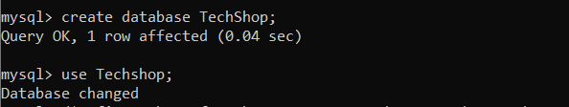

2. Define Schema for the Customer, Products, Order, OrderDetails, and Inventory table

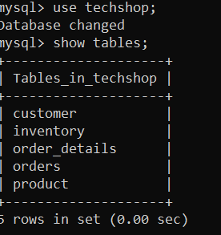

4. Create appropriate primary and foreign key constraints

Customer_id -🡪primary key;

Pdt_id -🡪primarykey

orders

Order_id-🡪primary key

Customer_id🡪foreign key

Orders detail

Order_detail_id🡪primarykey

Order_id-🡪foreign key

Pdt_id -🡪foreign key

inventory

Inv_id 🡪primary key

Pdt_id -🡪foreign key

Create tables

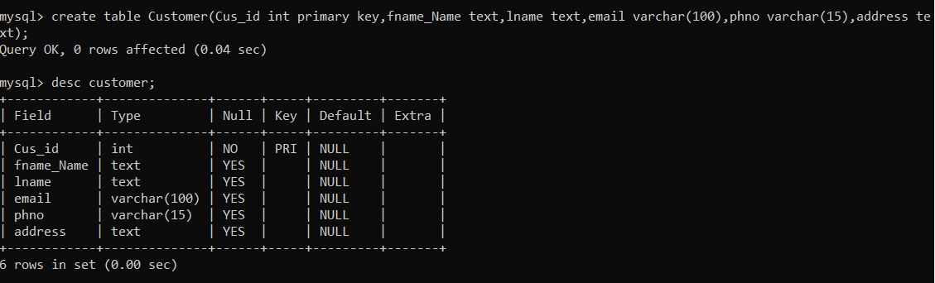

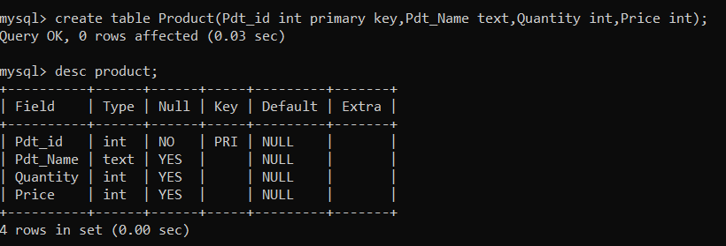

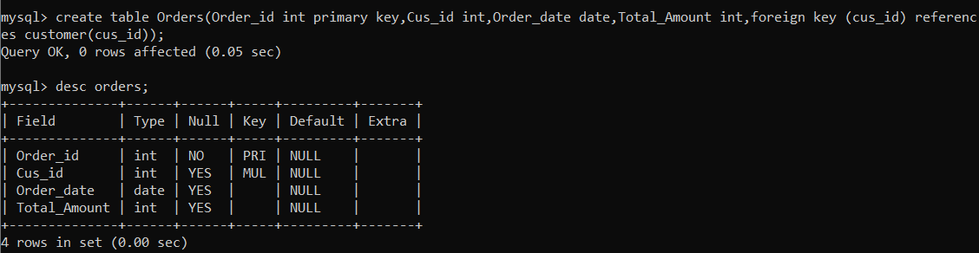

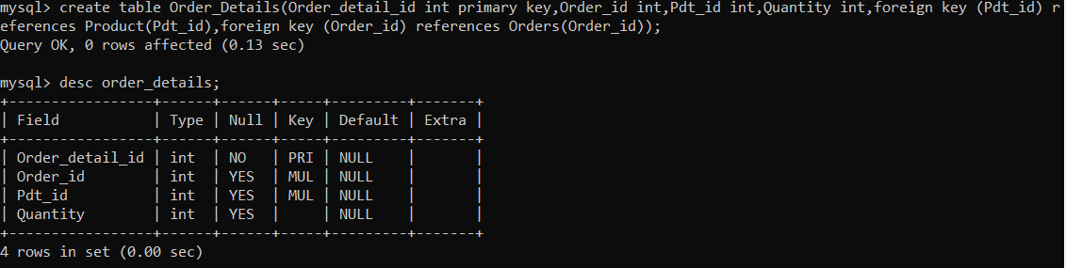

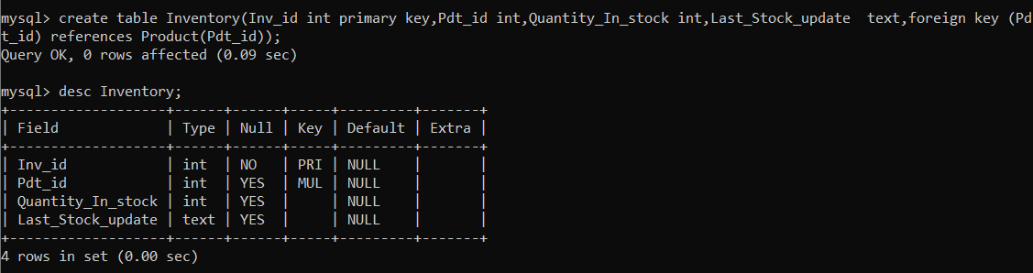

3.Create an ERD (entity relationship Diagram) for techshop database.

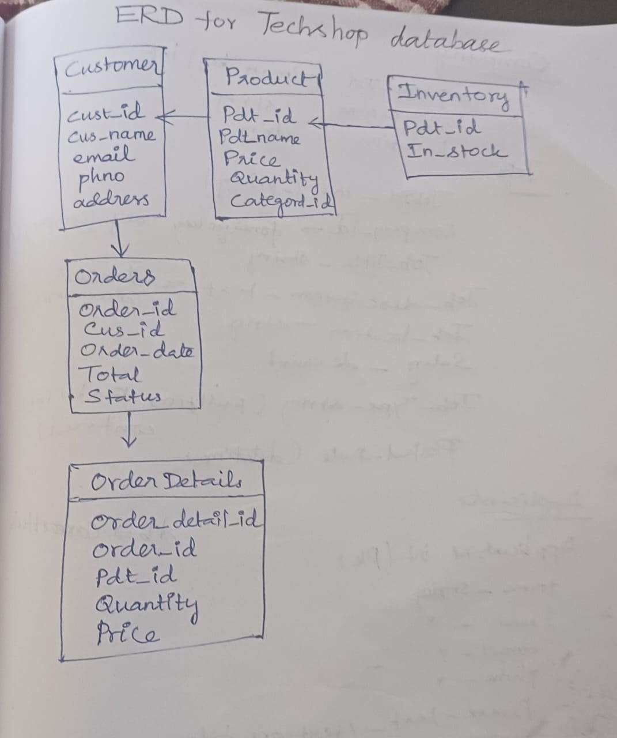

5.Insert at least 10sample records into each of the following tables.

a. Customer

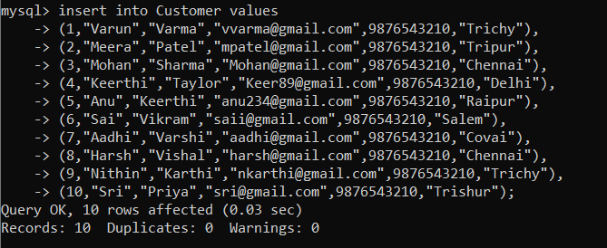

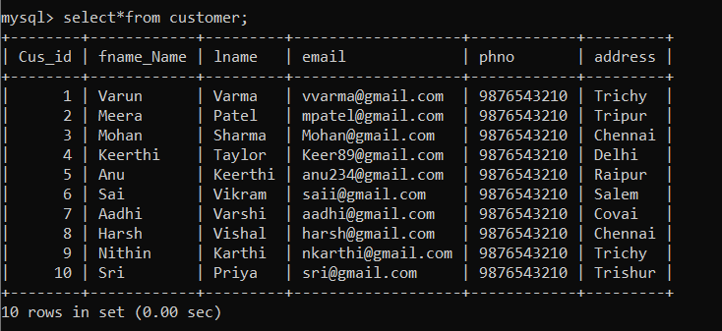

b. Products

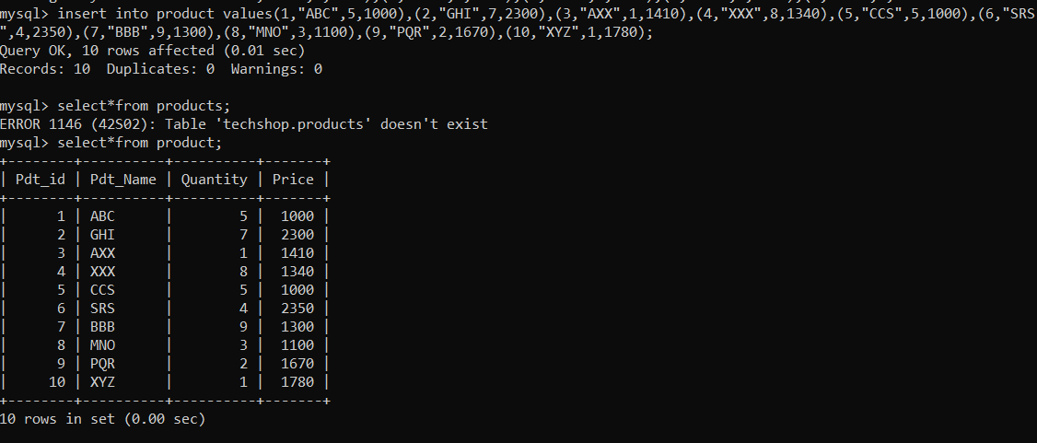

c. Orders



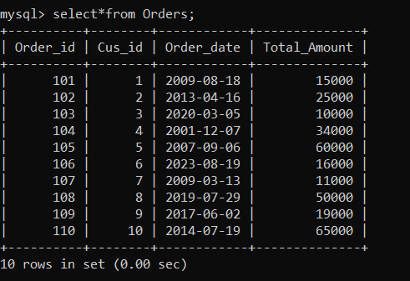

d. Order_Details

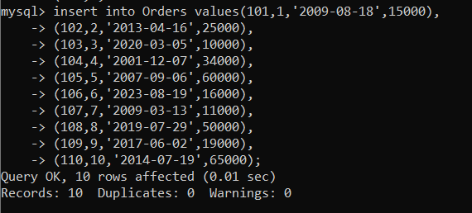

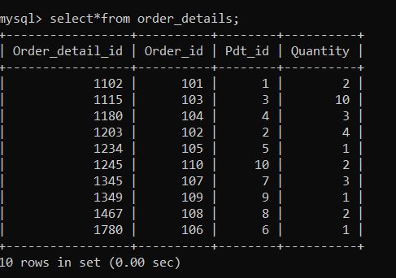

e. Inventory

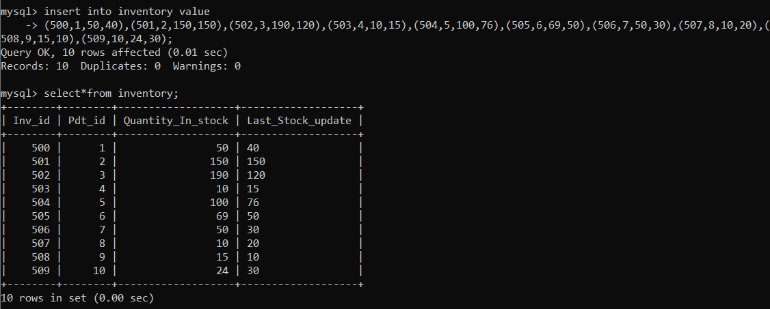

**Tasks 2:**

1. Retrieve email of all the customer

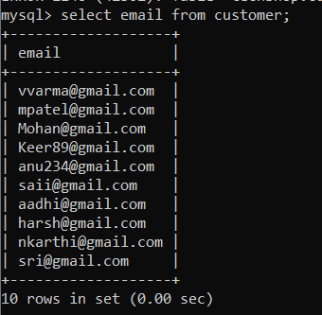

2.List orders with their order dates and customer names

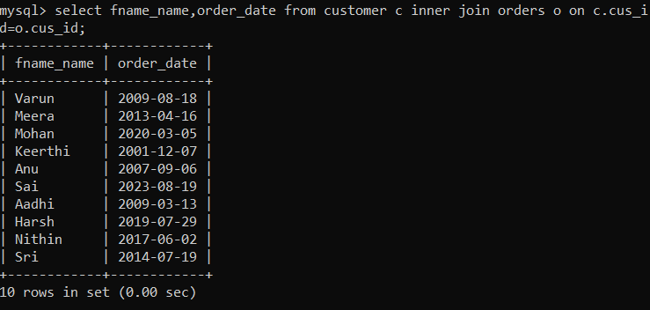

3. Insert a new customer record

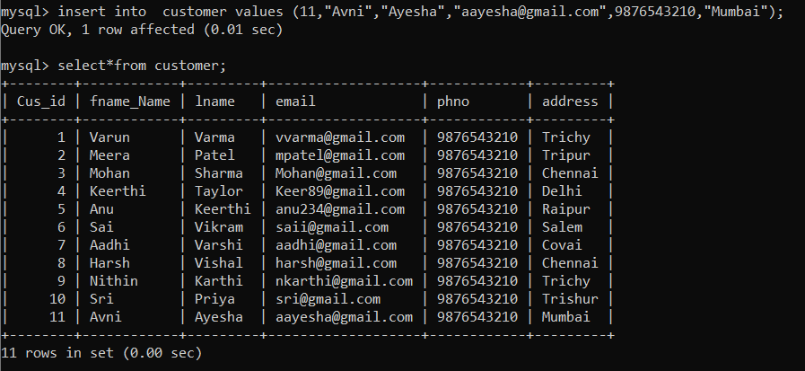

4.Update prices of electronic gadgets in products table

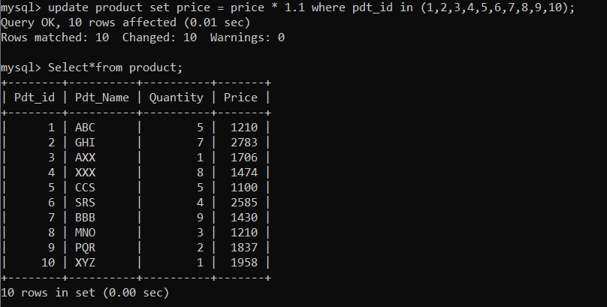

5. Write an SQL query to delete a specific order and its associated order details from the "Orders" and "OrderDetails" tables

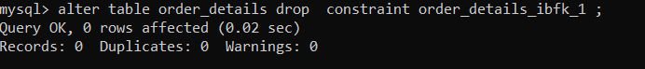

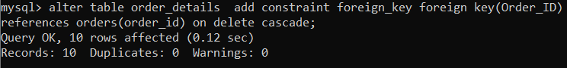

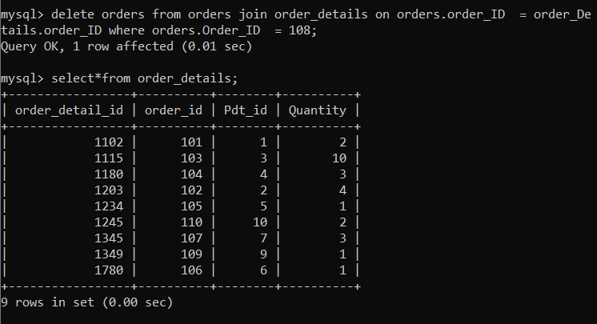

6. insert a new order into orders table

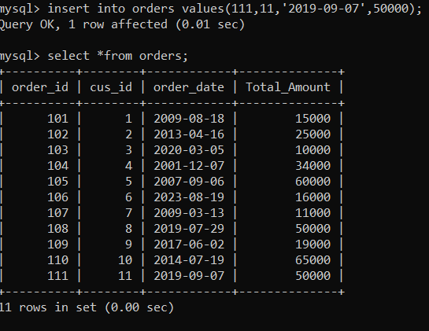

7. update the contact information

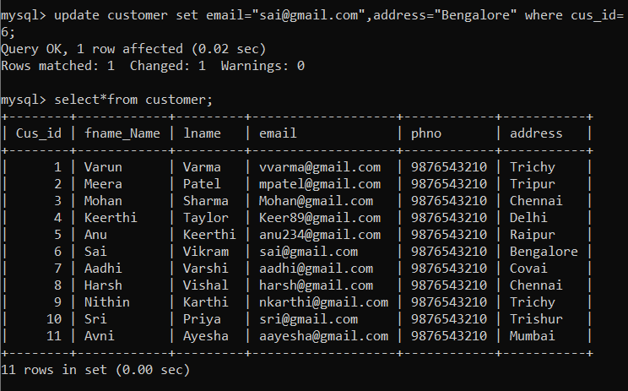

8.Recalculate and update the total cost

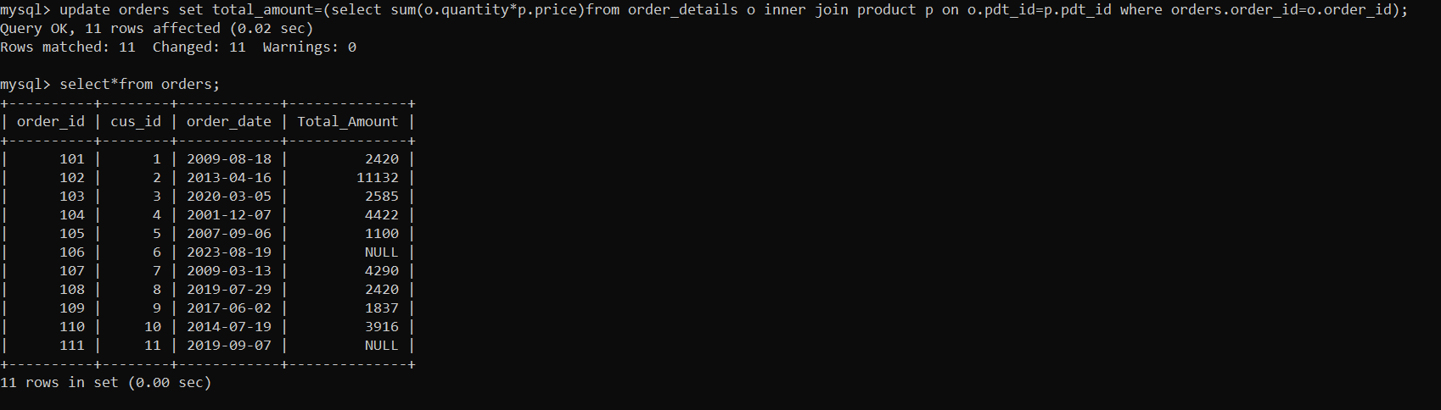

9. delete all orders and their associated order details for a specific customer

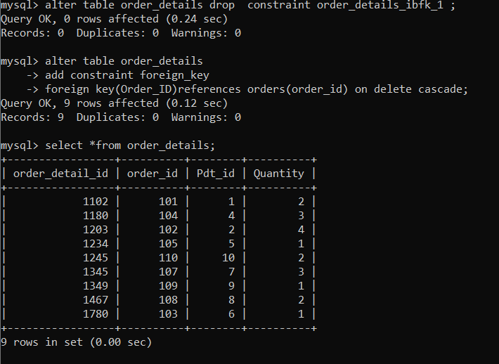

10.insert a new electronic gadget product into the products table

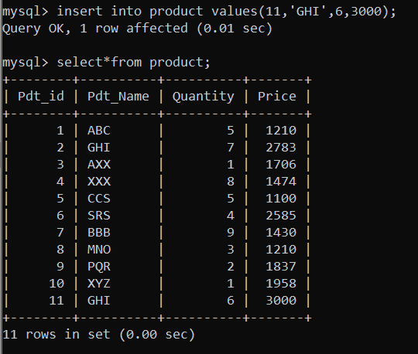

**TASK 3**

1. Retrieve a list of all orders along with customer information

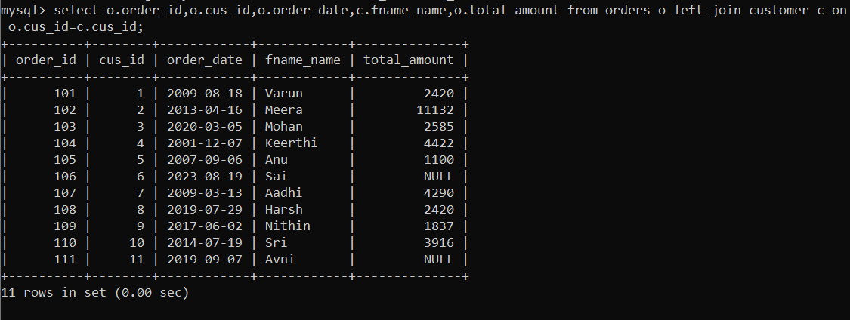

1. find the total revenue generated by each electronic gadget product. Include the product name and the total revenue

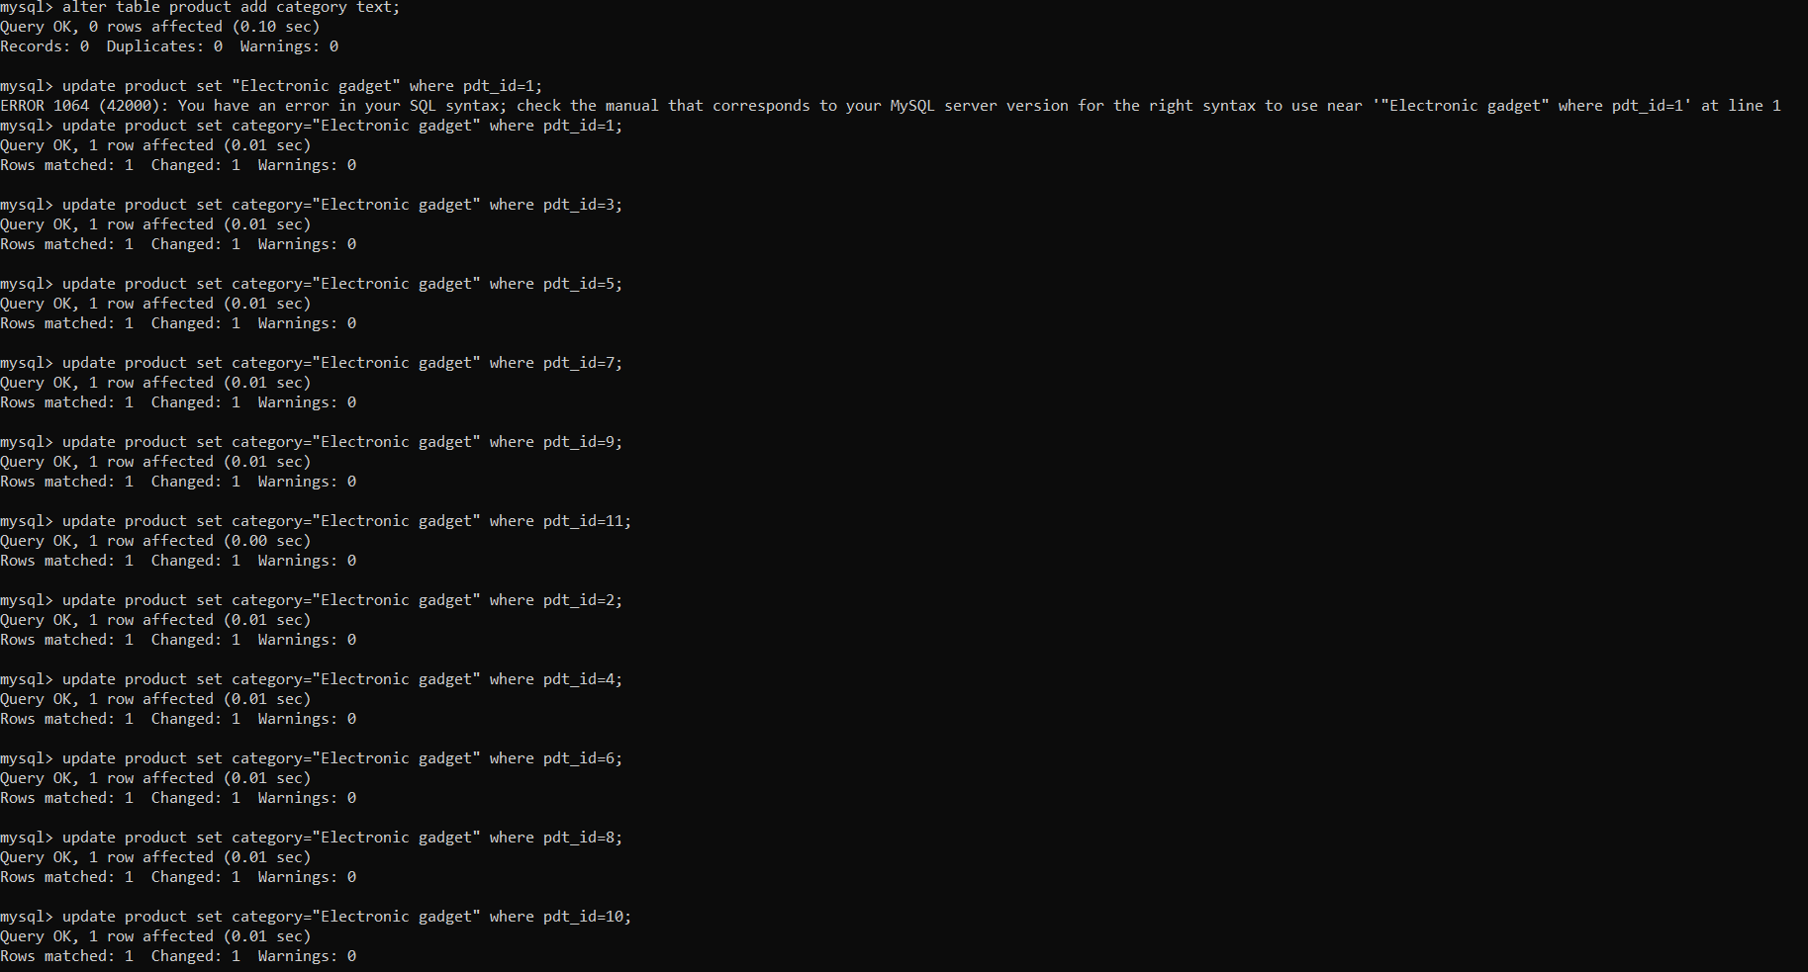

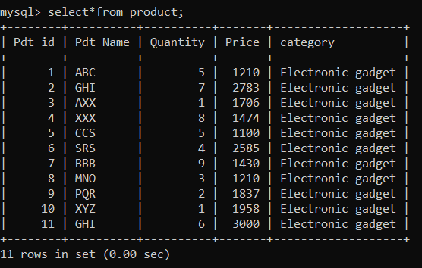

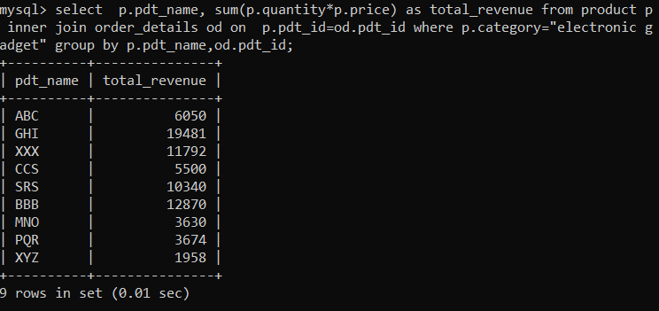

3. list all customers who have made at least one purchase, include their names and contact information

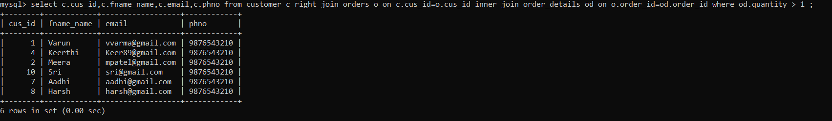

4. Find the most popular electronic gadget, which is the one with the highest total quantity ordered. Include the product name and the total quantity ordered

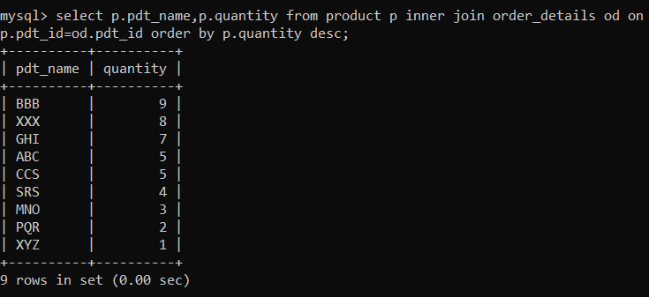

5.list of products and category

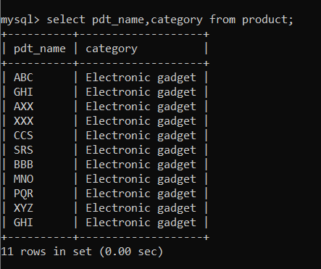

6. list average value of customer

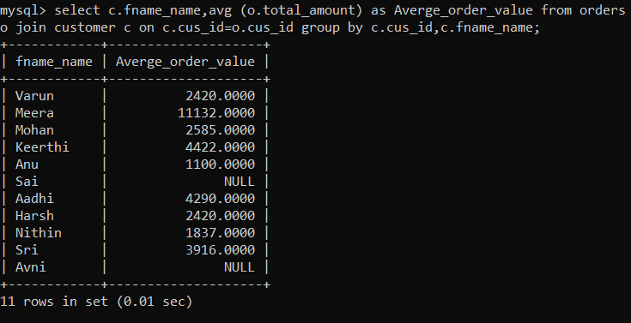

7. Write an SQL query to find the order with the highest total revenue. Include the order ID, customer information, and the total revenue.

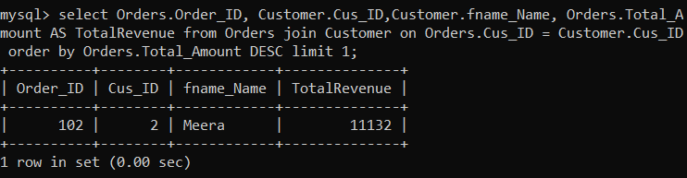

8. Write an SQL query to list electronic gadgets and the number of times each product has been ordered.

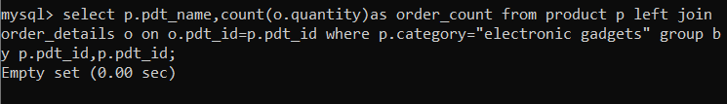

9. Write an SQL query to find customers who have purchased a specific electronic gadget product.

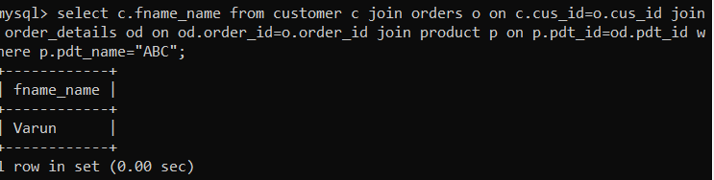

10. Write an SQL query to calculate the total revenue generated by all orders placed within a specific time period.

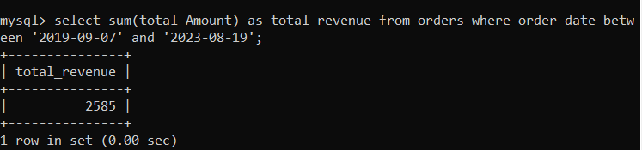

**Task 4.**

1. Write an SQL query to find out which customers have not placed any orders.

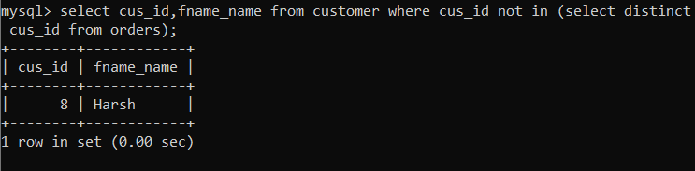

2. Write an SQL query to find the total number of products available for sale.

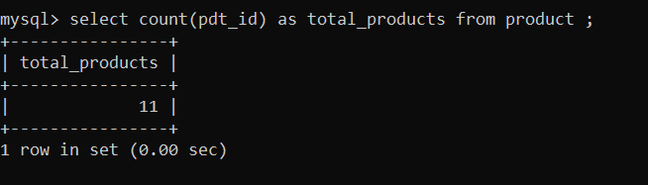

3. Write an SQL query to calculate the total revenue generated by TechShop.

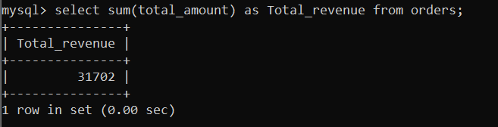

4. Write an SQL query to calculate the average quantity ordered for products in a specific category

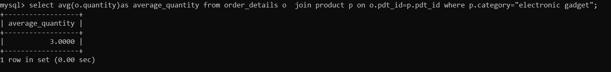

5. Write an SQL query to calculate the total revenue generated by a specific customer.

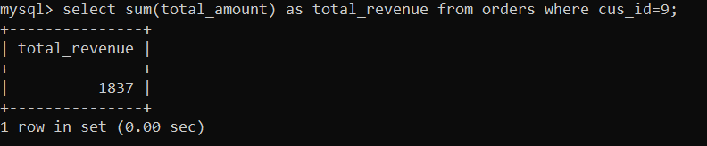

6. Write an SQL query to find the customers who have placed the most orders. List their names and the number of orders they've placed.

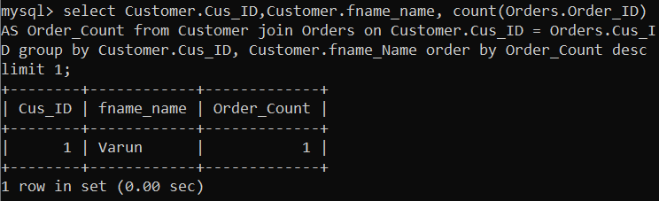

7. Write an SQL query to find the most popular product category, which is the one with the highest total quantity ordered across all orders.

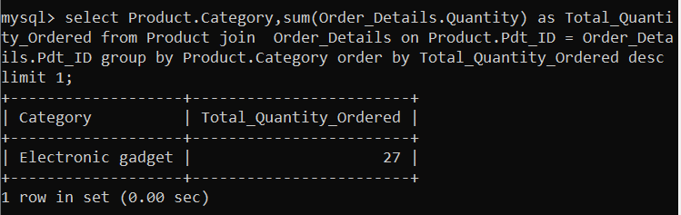

8. Write an SQL query to find the customer who has spent the most money (highest total revenue) on electronic gadgets. List their name and total spending.



9. Write an SQL query to calculate the average order value (total revenue divided by the number of orders) for all customers

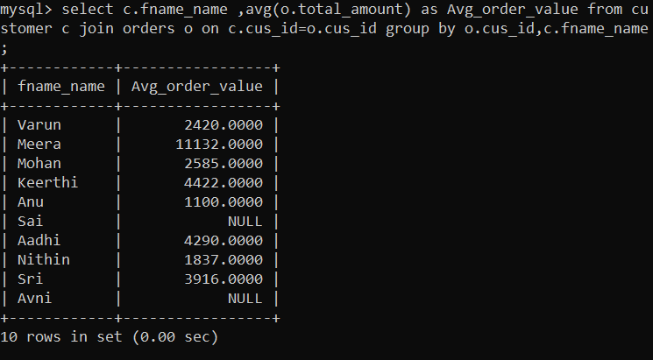

10. Write an SQL query to find the total number of orders placed by each customer and list their names along with the order count

